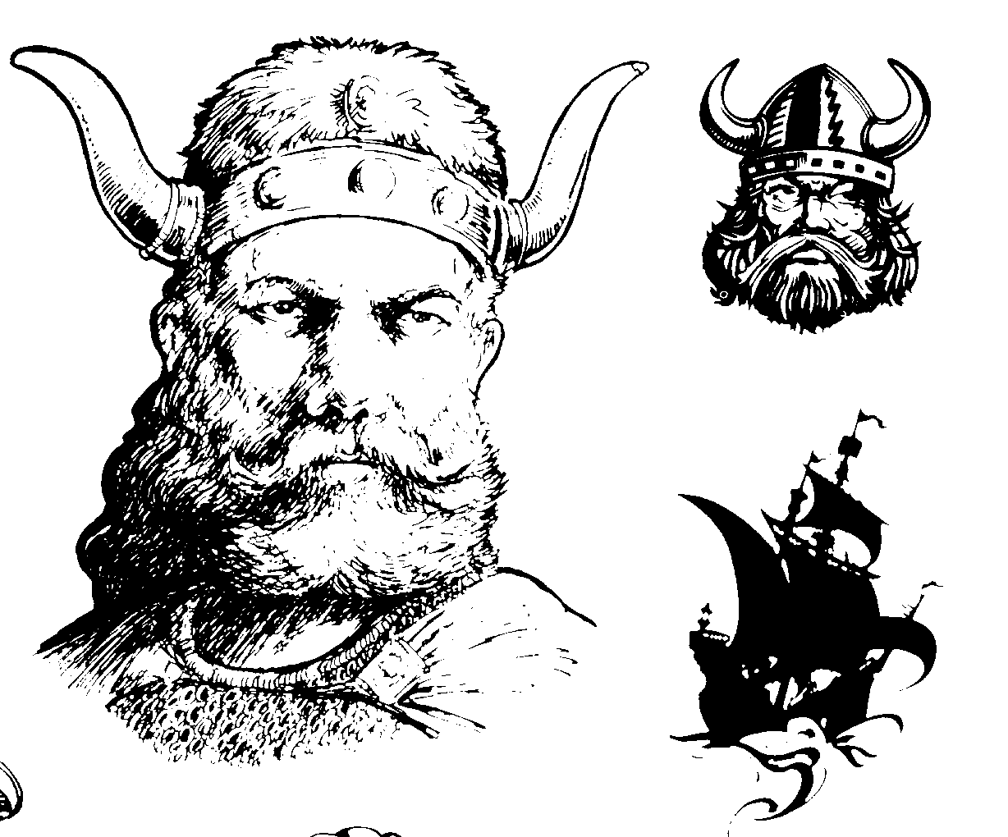

Married:
Place:

David & Beth Dahl
1 son; 3 adopted daughters;
1 grandson, [?]
+ 3 adopted grandchildren

Name: Elizabeth Hunter
B/Plc:
D/Plc:
Occupation:

Fourth Generation Norwegian American
Son of Adrian [III] and Virginia Dahl

Name: David Adrian Dahl
B/Plc: 5 June 1944,
D/Plc:
Occupation:,,consultant to US government; electrical enginee.
S/C:

Name:
B/Plc:
D/Plc:
Occupation:
S/C:

Name: Steven Dahl
B/Plc:
D/Plc:
Occupation: BP anchorage
S/C: chem e. janie

Name:
B/Plc:
D/Plc:
Occupation:
S/C:

Name:
B/Plc:
D/Plc:
Occupation:
S/C:



[ III ] Family Tree Branches: Adrian Hilman Dahl

Name: Adrian Hillman Dahl
B/Plc: 6 December 1919
D/Plc: 2005?; Loveland, CO
Occupation: Nuclear Physicist; professor

Married:
Place:

Adrian & Virginia Ddahl
1 son; 1 daughter
4 grandsons, [?]
+ 3 adopted grandchildren

Name: Virginia
B/Plc:
D/Plc:
Occupation:

Third Generation Norwegian American
Son of Tonetta Marthia [II] (“Nettie”) & Frederick Dahl

Name: David Adrian Dahl
B/Plc: 5 June 1944
D/Plc:
Occupation:
S/C:

Name: Sonje Ann Dahl Jessem
B/Plc: 1 July 1946
D/Plc:
Occupation:
S/C:

